1. **PENGENALAN VISUAL BASIC**

Public Class Form1

Private Sub Button1_Click(ByVal sender As System.Object, ByVal e As System.EventArgs) Handles Button1.Click

MessageBox.Show(TextBox1.Text & vbCrLf & ComboBox1.Text & vbCrLf & ComboBox2.Text, "Hasil Pengisian", MessageBoxButtons.OK, MessageBoxIcon.Information)

End Sub

End Class

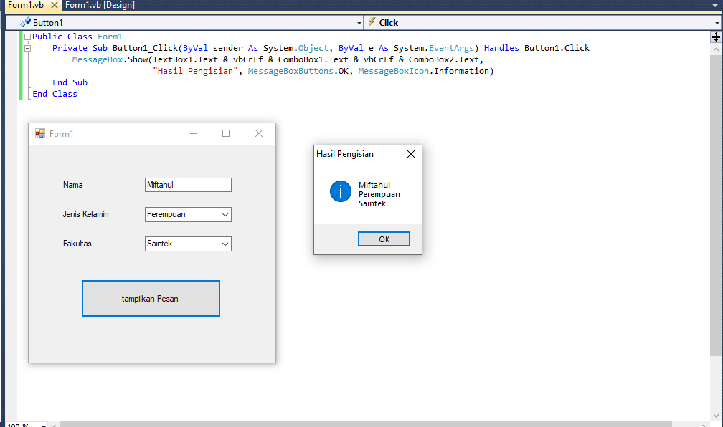

1. **VARIABLE, TIPE DATA DAN OPERATOR**
2. **Variable**

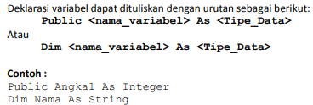

1. **Tipe Data**

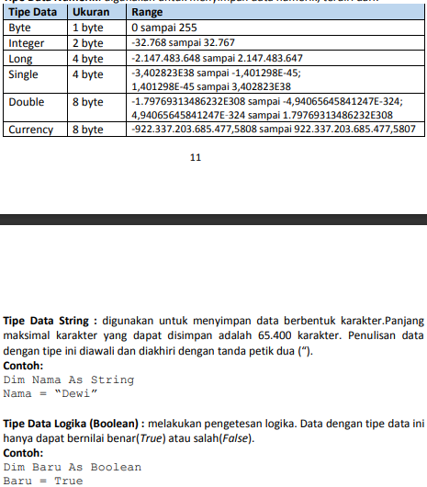



1. **Operator**

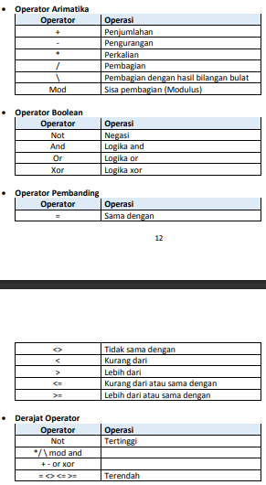



Public Class Form1

Private Sub Button1_Click(ByVal sender As System.Object, ByVal e As System.EventArgs) Handles Button1.Click

Dim angka1, angka2, hasil As Double

angka1 = Val(TextBox1.Text)

angka2 = Val(TextBox2.Text)

hasil = angka1 + angka2

TextBox3.Text = hasil

MessageBox.Show(TextBox3.Text, "Hasil pertambahannya adalah", MessageBoxButtons.OK, MessageBoxIcon.Information)

End Sub

Private Sub Button2_Click(ByVal sender As System.Object, ByVal e As System.EventArgs) Handles Button2.Click

Dim angka1, angka2, hasil As Double

angka1 = Val(TextBox1.Text)

angka2 = Val(TextBox2.Text)

hasil = angka1 - angka2

TextBox3.Text = hasil

MessageBox.Show(TextBox3.Text, "Hasil Pengurangannya adalah", MessageBoxButtons.OK, MessageBoxIcon.Information)

End Sub

Private Sub Button3_Click(ByVal sender As System.Object, ByVal e As System.EventArgs) Handles Button3.Click

Dim angka1, angka2, hasil As Double

angka1 = Val(TextBox1.Text)

angka2 = Val(TextBox2.Text)

hasil = angka1 / angka2

TextBox3.Text = hasil

MessageBox.Show(TextBox3.Text, "Hasil Pembagiannya adalah", MessageBoxButtons.OK, MessageBoxIcon.Information)

End Sub

Private Sub Button4_Click(ByVal sender As System.Object, ByVal e As System.EventArgs) Handles Button4.Click

Dim angka1, angka2, hasil As Double

angka1 = Val(TextBox1.Text)

angka2 = Val(TextBox2.Text)

hasil = angka1 * angka2

TextBox3.Text = hasil

MessageBox.Show(TextBox3.Text, "Hasil Perkaliannya adalah", MessageBoxButtons.OK, MessageBoxIcon.Information)

End Sub

End Class

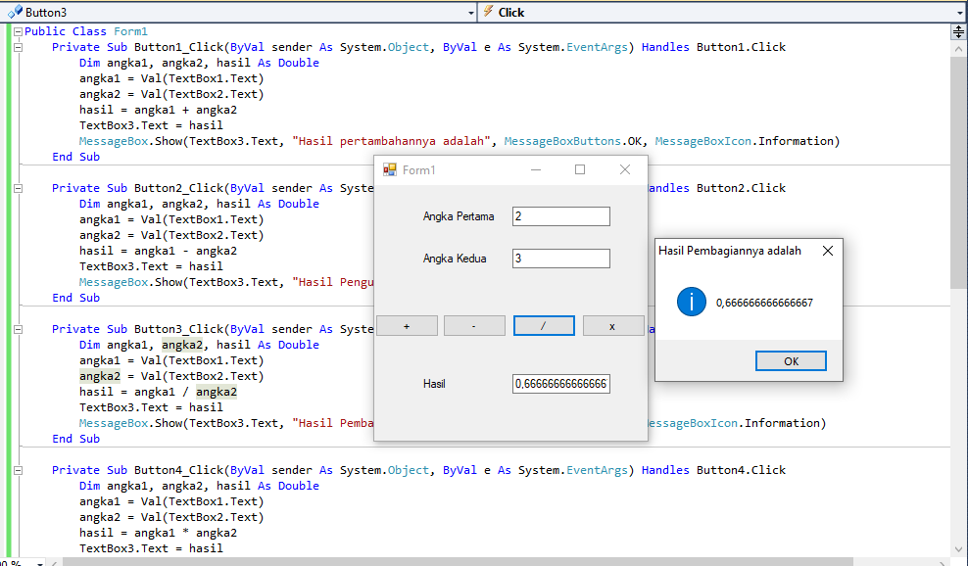

Public Class Form1

Private Sub Button1_Click(ByVal sender As System.Object, ByVal e As System.EventArgs) Handles Button1.Click

Dim a, b, c, hasil As Double

a = Val(TextBox1.Text)

b = Val(TextBox2.Text)

c = Val(TextBox3.Text)

hasil = (a + b + c) / 3

TextBox4.Text = hasil

MessageBox.Show(TextBox4.Text, "Hasil", MessageBoxButtons.OK, MessageBoxIcon.Information)

End Sub

End Class

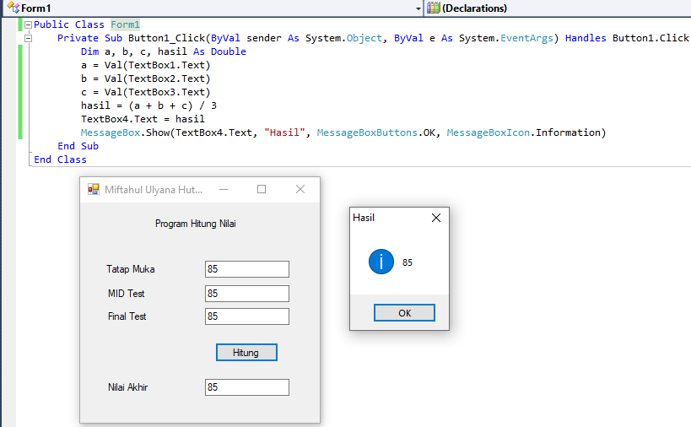

1. **PERCABANGAN/PEMILIHAN**
2. **If…Then**

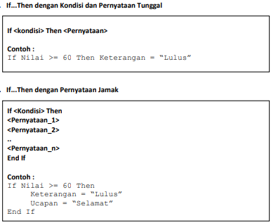

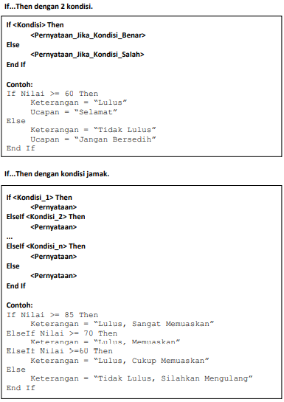

1. **Select Case**

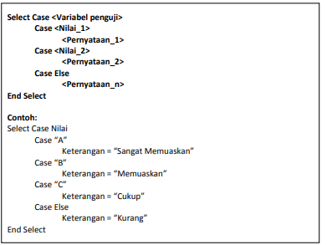

Public Class Form1

Private Sub Button1_Click(ByVal sender As System.Object, ByVal e As System.EventArgs) Handles Button1.Click

Dim harga, jumlah, total, diskon, bayar As Double

Dim bonus As String

harga = TextBox2.Text

jumlah = TextBox3.Text

total = harga * jumlah

If total >= 500000 Then

diskon = 20 * total / 100

bonus = "tas pinggang"

ElseIf total >= 200000 & total <= 500000 Then

diskon = 15 * total / 100

bonus = "Payung"

ElseIf total >= 100000 & total <= 200000 Then

diskon = 10 * total / 100

bonus = "Kaos"

ElseIf total >= 50000 & total <= 100000 Then

diskon = 5 * total / 100

bonus = "Cangkir"

ElseIf total <= 50000 Then

diskon = 0

bonus = "Tidak Ada"

End If

bayar = total - diskon

TextBox4.Text = total

TextBox5.Text = diskon

TextBox6.Text = bayar

TextBox7.Text = bonus

MessageBox.Show(TextBox3.Text & " " & TextBox1.Text & " = " & TextBox6.Text & vbCrLf & "bonus = " & TextBox7.Text, "HARGA", MessageBoxButtons.OK, MessageBoxIcon.Information)

End Sub

Private Sub Button2_Click(ByVal sender As System.Object, ByVal e As System.EventArgs) Handles Button2.Click

TextBox1.Text = ""

TextBox2.Text = ""

TextBox3.Text = ""

TextBox4.Text = ""

TextBox5.Text = ""

TextBox6.Text = ""

TextBox7.Text = ""

End Sub

Private Sub Button3_Click(ByVal sender As System.Object, ByVal e As System.EventArgs) Handles Button3.Click

End

End Sub

End Class

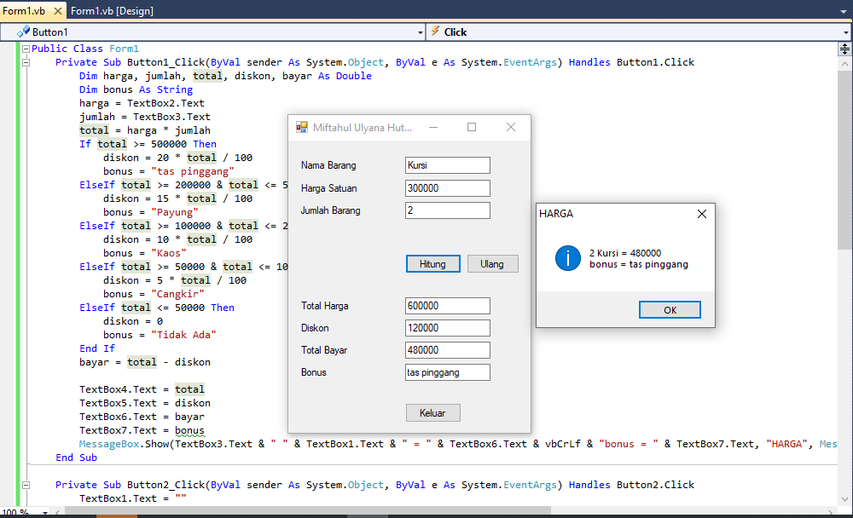

Public Class Form1

Public hrgmakan, hrgminum As Integer

Private Sub ComboBox1_SelectedIndexChanged(ByVal sender As System.Object, ByVal e As System.EventArgs) Handles ComboBox1.SelectedIndexChanged

Select Case ComboBox1.Text

Case "Nasi Uduk"

Label2.Text = "Rp.10.000"

hrgmakan = 10000

Case "Lontong Sayur"

Label2.Text = "Rp.8.000"

hrgmakan = 8000

Case "Lontong Kacang"

Label2.Text = "Rp.8.000"

hrgmakan = 8000

Case "Lupes"

Label2.Text = "Rp.5.000"

hrgmakan = 5000

End Select

End Sub

Private Sub ComboBox2_SelectedIndexChanged(ByVal sender As System.Object, ByVal e As System.EventArgs) Handles ComboBox2.SelectedIndexChanged

Select Case ComboBox2.Text

Case "Teh Manis"

Label4.Text = "Rp.5.000"

hrgminum = 5000

Case "Kopi"

Label4.Text = "Rp.5.000"

hrgminum = 5000

Case "Air Putih"

Label4.Text = "Rp.2.000"

hrgminum = 2000

End Select

End Sub

Public Sub New()

InitializeComponent()

ComboBox2.Visible = False

Label3.Visible = False

Label4.Visible = False

End Sub

Private Sub CheckBox1_CheckedChanged(ByVal sender As System.Object, ByVal e As System.EventArgs) Handles CheckBox1.CheckedChanged

If CheckBox1.Enabled = False Then

ComboBox2.Visible = False

Label3.Visible = False

Label4.Visible = False

ElseIf CheckBox1.Enabled = True Then

ComboBox2.Visible = True

Label3.Visible = True

Label4.Visible = True

End If

End Sub

Private Sub Button1_Click(ByVal sender As System.Object, ByVal e As System.EventArgs) Handles Button1.Click

Dim prsmakan, prsminum, hitung As Integer

prsmakan = TextBox1.Text

prsminum = TextBox2.Text

hitung = (hrgmakan * prsmakan) + (hrgminum * prsminum)

Label7.Text = "Rp." & hitung.ToString

MessageBox.Show(TextBox1.Text & " " & ComboBox1.Text & " & " & TextBox2.Text & " " & ComboBox2.Text & " = " & Label7.Text, "HARGA", MessageBoxButtons.OK, MessageBoxIcon.Information)

End Sub

End Class

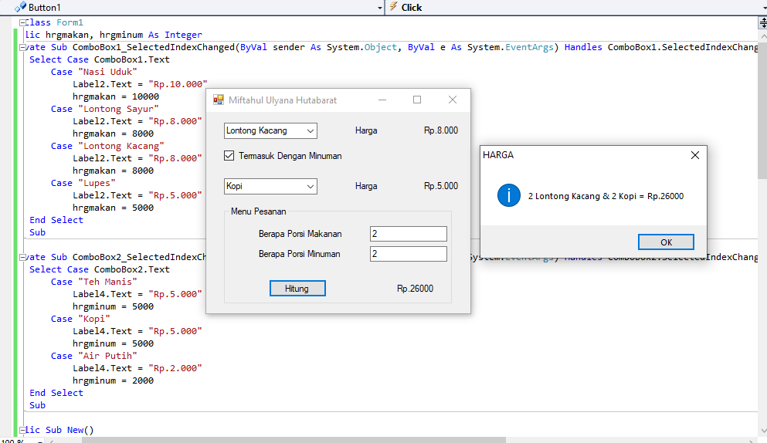

1. **PERULANGAN**
2. **For…Next**

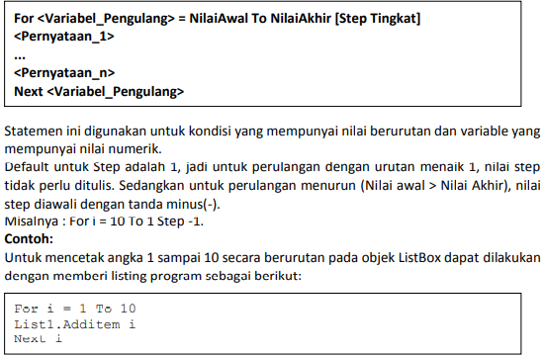

1. **Do…Loop**

* **Do…while**

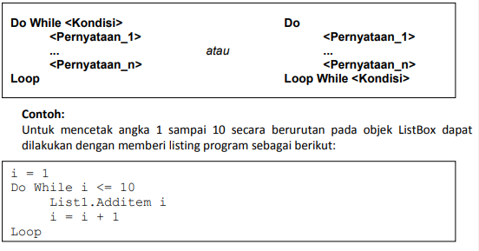

* **Do…Until**

D:\gambar\8.png

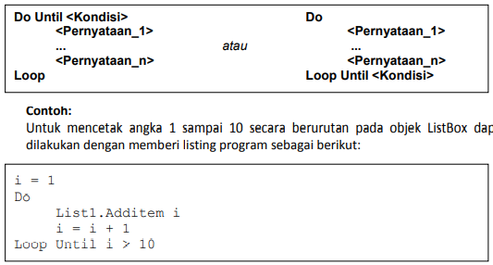

Public Class Form1

Private Sub Button1_Click(ByVal sender As System.Object, ByVal e As System.EventArgs) Handles Button1.Click

Dim tulis As String

Dim jumlah, i As Integer

tulis = TextBox1.Text

jumlah = TextBox2.Text

For i = 1 To jumlah

ListBox1.Items.Add(i & ". " & tulis)

Next i

End Sub

Private Sub Button2_Click(ByVal sender As System.Object, ByVal e As System.EventArgs) Handles Button2.Click

TextBox1.Text = ""

TextBox2.Text = ""

ListBox1.Items.Clear()

End Sub

Private Sub Button3_Click(ByVal sender As System.Object, ByVal e As System.EventArgs) Handles Button3.Click

End

End Sub

End Class

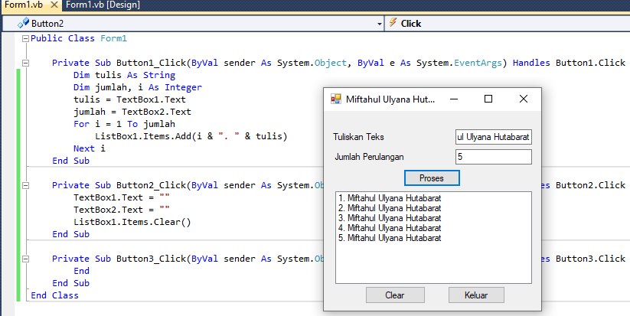

Public Class Form1

Public miftah As String, i As Integer

Private Sub Button1_Click(ByVal sender As System.Object, ByVal e As System.EventArgs) Handles Button1.Click

miftah = ". Miftahul Ulyana Hutabarat"

For i = 1 To 10

ListBox1.Items.Add("for Next: " & i & miftah)

Next i

End Sub

Private Sub Button2_Click(ByVal sender As System.Object, ByVal e As System.EventArgs) Handles Button2.Click

miftah = ". Miftahul Ulyana Hutabarat"

i = 1

Do While i <= 10

ListBox1.Items.Add("Do While: " & i & miftah)

i += 1

Loop

End Sub

Private Sub Button3_Click(ByVal sender As System.Object, ByVal e As System.EventArgs) Handles Button3.Click

miftah = ". Miftahul Ulyana Hutabarat"

i = 1

Do

ListBox1.Items.Add("Do Until: " & i & miftah)

i += 1

Loop Until i > 10

End Sub

End Class

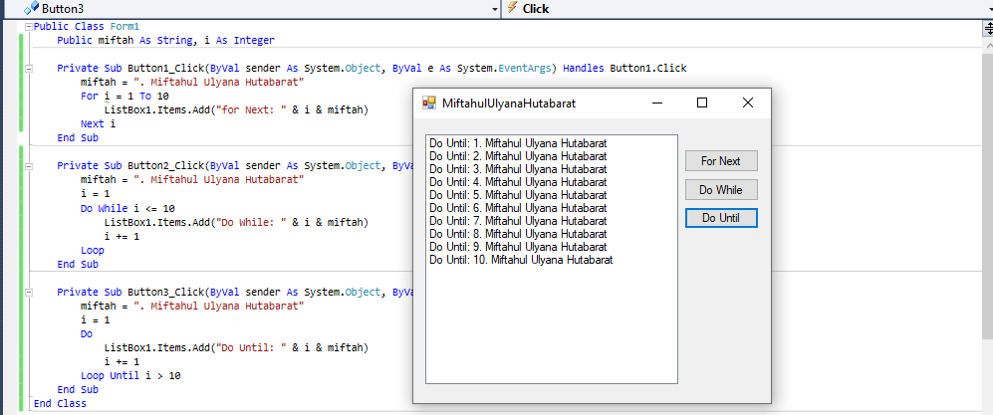

1. **ARRAY**
2. **PROCEDURE, FUNCTION & MODULE**
3. **Procedure**

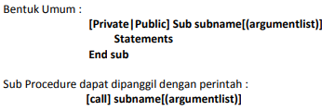

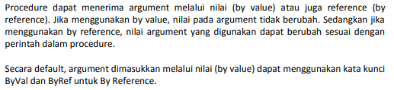

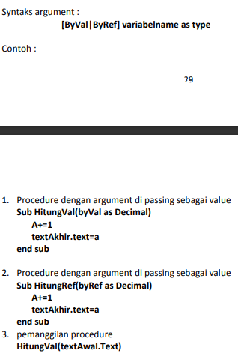



1. **Function**

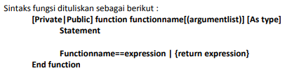

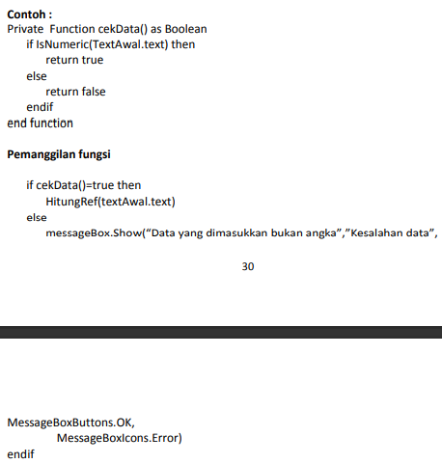



1. **Module**

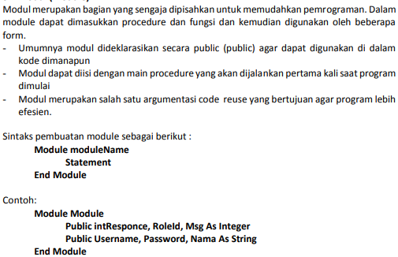

Public Class Form1

Private Function Hitung()

Dim harga, jumlah, total As Integer

harga = TextBox4.Text

jumlah = TextBox5.Text

total = harga * jumlah

TextBox6.Text = total

Return total

End Function

Sub cekdatakosong()

If TextBox1.Text = "" Then

MessageBox.Show("kode barang harus diisi!", "konfirmasi", MessageBoxButtons.OK, MessageBoxIcon.Warning)

TextBox1.Focus()

ElseIf TextBox2.Text = "" Then

MessageBox.Show("nama barang harus diisi!", "konfirmasi", MessageBoxButtons.OK, MessageBoxIcon.Warning)

TextBox2.Focus()

ElseIf TextBox3.Text = "" Then

MessageBox.Show("satuan barang harus diisi!", "konfirmasi", MessageBoxButtons.OK, MessageBoxIcon.Warning)

TextBox3.Focus()

ElseIf TextBox4.Text = "" Then

MessageBox.Show("harga barang harus diisi!", "konfirmasi", MessageBoxButtons.OK, MessageBoxIcon.Warning)

TextBox4.Focus()

ElseIf TextBox5.Text = "" Then

MessageBox.Show("jumlah barang harus diisi!", "konfirmasi", MessageBoxButtons.OK, MessageBoxIcon.Warning)

TextBox5.Focus()

Else

Call Hitung()

End If

End Sub

Private Sub Button1_Click(ByVal sender As System.Object, ByVal e As System.EventArgs) Handles Button1.Click

Call cekdatakosong()

End Sub

Private Sub Button2_Click(ByVal sender As System.Object, ByVal e As System.EventArgs) Handles Button2.Click

TextBox1.Text = ""

TextBox2.Text = ""

TextBox3.Text = ""

TextBox4.Text = ""

TextBox5.Text = ""

TextBox6.Text = ""

TextBox6.Enabled = False

End Sub

Private Sub Button3_Click(ByVal sender As System.Object, ByVal e As System.EventArgs) Handles Button3.Click

Dim tutup As String

tutup = MessageBox.Show("yakin tutup form ini?", "konfirmasi", MessageBoxButtons.YesNo, MessageBoxIcon.Question)

If tutup = MsgBoxResult.Yes Then

End

Else

Exit Sub

End If

End Sub

End Class

